H.T No
Regulations:
A15

Sreenidhi Institute of Science and Technology
(An Autonomous Institution)
Code No: 5K502 Date: 12-Oct-2020 (AN)

B.Tech III-Year I-Semester External Examination, October - 2020 (Supplementary)
Structural Analysis - II (CIVIL)

Time: 2 Hours Max.Marks:75

Note: a) No additional answer sheets will be provided.
b) All sub-parts of a question must be answered at one place only, otherwise it will not be valued.
c) Missing data can be assumed suitably.

ANSWER ANY 5 OUT OF 8 QUESTIONS. EACH QUESTION CARRIES 15 MARKS.

1. |  | Illustrate the forces in through type truss members in U₃U₄, L₆L₇, U₂U₁ and L₂L₃ shown in figure using ILD.  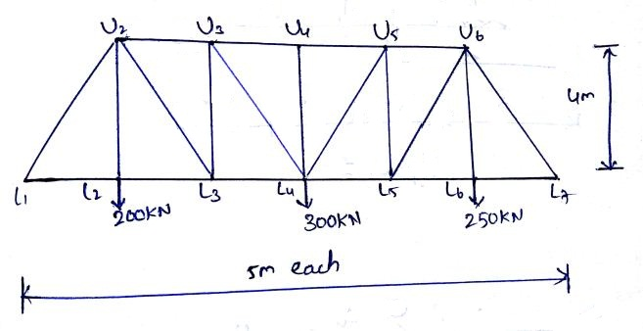 | [15M]
2. |  | Analyse the three hinged symmetrical parabolic arch of span 18m with central rise of 6m. The left span carries a concentric load of 50kN at 4m from left. The right span carries an UDL of 25kN/m. Determine Reactions, Bending moment, Normal Thrust, Radial Shear at 6m from left support. | [15M]
3. |  | A suspension bridge of 120m span has two hinged stiffening girders supported by two cables having a central dip of 12m. The dead load on the bridge is 6kN/m² and the live load is 12kN/m² on left half of the span. The width of road way is 6m. Determine the shear force and bending moment for the girder at 30m from the left end. Find also the maximum tension for this position of load. | [15M]
4. |  | Analyse the continuous beam shown below by using Flexibility method. Take EI as constant.  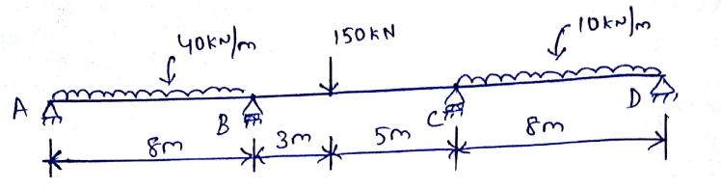 | [15M]
5. |  | Analyse the continuous beam shown below by using stiffness method.  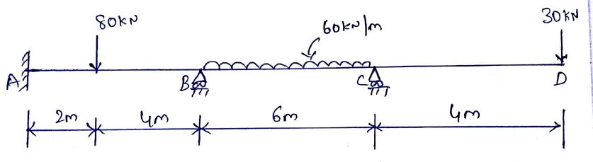 | [15M]
6. |  | Calculate the plastic moment capacity required for the continuous beam shown below.  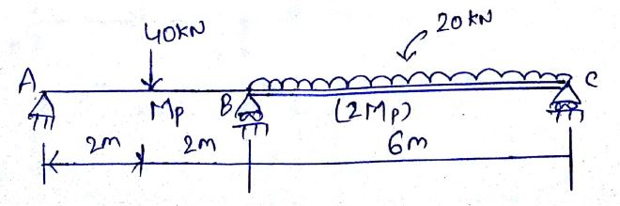 | [15M]
7. |  | Generate the stiffness matrix for the continuous beam shown below.  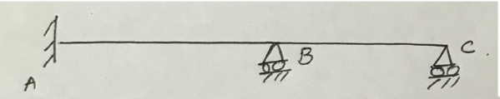 | [15M]
8. |  | Determine the shape factor of the T-section shown below.  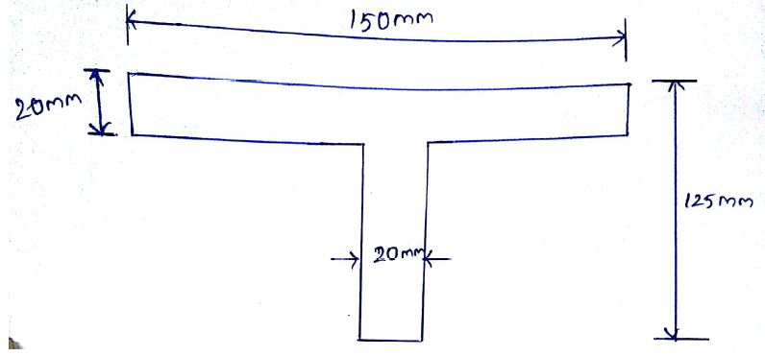 | [15M]

-- 00 -- 00 –

